- Create a table listing 3 types of printers, 2 types of scanners, and 2 types of webcams, and for each, write one real-life use case (for example: 'Inkjet printer – printing college assignments').
Ans :- Types of Printers, Scanners and Webcams
Device type Real-life use case
Inkjet printer Printing college assignments and colour photos.
Laser printer Printing office documents quickly.
Dot matrix printer Printing bills and multi-copy receipts.
Flatbed scanner Scanning documents, certificates and photos.
Handheld scanner Scanning barcodes in shops and supermarkets.
Built-in webcam Attending online classes on a laptop.
External USB webcam Making video calls on a desktop computer.
- Draw a labeled diagram showing how a typical home printer connects to a laptop or PC, including the connection interface used (USB, Wi-Fi, or Bluetooth).
Ans :- The following diagram shows a printer connected to a laptop using a USB cable.
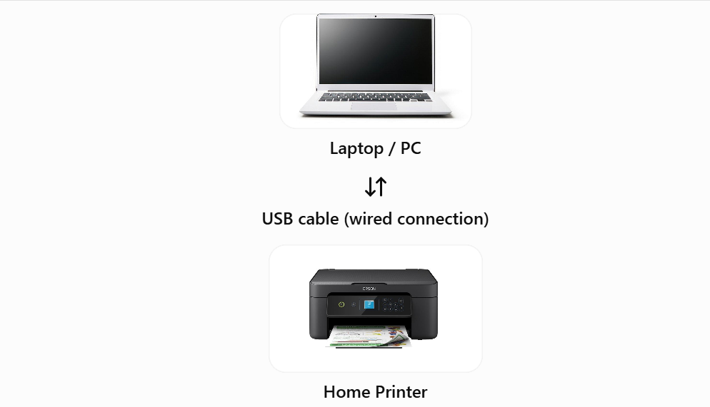
Other connection methods:
- Wi-Fi: Connects the printer and computer through the same wireless network.
- Bluetooth: Connects compatible devices wirelessly over a short distance.
- List three different connection interfaces (such as USB, Wi-Fi, Bluetooth) used by peripherals like printers, scanners, and webcams, and for each, name one advantage and one disadvantage.<br><br><em><strong>Hint:</strong> Think about speed, convenience, and compatibility.</em>
Ans :- Interface Advantage Disadvantage
USB Fast and reliable connection. Requires a cable.
Wi-Fi Allows wireless printing from Requires a working network and
different devices. and proper setup.
Bluetooth Wireless and easy to connect over Has limited range and may be
short distances. slower than USB.
- Pick any one device you use at home or college (printer, scanner, or webcam). Write step-by-step instructions for how you would connect it to your computer, including what cable or wireless method you would use and any setup steps required.
Ans :- Connecting a home printer to a laptop using a USB cable.
- Place the printer: Keep the printer near the computer and connect it to a power socket.
- Turn it on: Switch on the printer and check that it is ready.
- Connect the USB cable: Plug one end into the printer and the other end into the laptop.
- Install the driver: Allow Windows to install the printer driver automatically, or download the correct driver from the printer manufacturer's official website if needed.
- Open printer settings: On Windows, go to Settings → Bluetooth & devices → Printers & scanners.
- Add the printer: If it does not appear automatically, select Add device and follow the instructions.
- Print a test page: Open a document, press Ctrl + P, select your printer and click Print.

